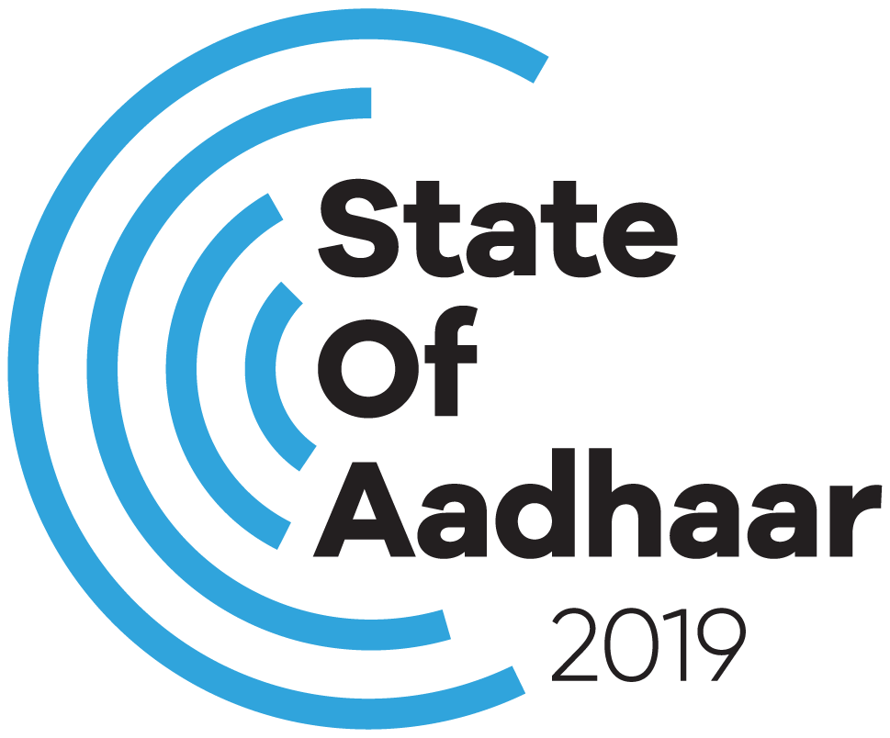

**State of Aadhaar 2019:**

**Pulse survey Questionnaire**

State of Aadhaar 2019  
Pulse survey questionnaire

1. Aadhaar Questions 3
2. Descriptive Variables 5

Demographics 5

Geography 7

# Aadhaar Questions

| **Question ID** | **Question (English)** | **Options** | **Entrance Condition** |
| --- | --- | --- | --- |
| 1 | Do you have an Aadhaar card? | 1. Don't Know 2. I Lost it 3. No 4. No Response 5. Yes | Respondents answered on behalf of those members who are not present on date of the survey. |
| 2 | Is the … given on your Aadhaar card correct?   1. Name 2. Date of Birth 3. Gender 4. Address 5. Photograph 6. Mobile Number | 1. Don't Know 2. No 3. No Response 4. Yes | All members that have Aadhaar (chose ‘option 5. Yes’ or ‘option 2. I Lost it’ in question 1). |
| 3 | Have you personally used Aadhaar for …?   1. MNREGA 2. Other Employment Schemes 3. Receiving Payments from Government Schemes 4. Social Security and Pensions 5. Workers' Pension Scheme 6. Ayushmaan Bharat 7. Scholarships 8. Opening a Bank Account 9. Making Payments 10. Insurance 11. Debt/Loan 12. SIM card/mobile phone 13. School/College Enrollment/Attendance 14. Mid-day Meals 15. Transport (train/bus/metro/flight) 16. Getting Another ID (passport/voter ID/driver's license) 17. Job Application 18. Age proof 19. Any Land/Vehicle/House/Marriage registration | 1. Don't Know 2. No 3. No Response 4. Yes | All members that have Aadhaar (chose either ‘option 5. Yes’ or ‘option 2. I Lost it’ in question 1).  In case of MNREGA and Job Application, we ask the questions only to members whose age is greater or equal to 15. |
| 4 | Have you personally used Aadhaar for …?   1. PDS Ration 2. LPG Subsidy 3. Kerosene Subsidy 4. Fertilizer Subsidy | 1. Don't Know 2. No 3. No Response 4. Yes | Only respondents |
| 5 | Do you get … currently?   1. PDS Ration 2. Employment under MNREGA 3. Social Security & Pensions | 1. Don't Know 2. No Response 3. No, we don't get the service 4. Yes, we get the service 5. Yes, we get the service but not in full | Only respondents |
| 6 | Has accessing … become easier or difficult for you due to the introduction of Aadhaar?   1. PDS Ration 2. MNREGA 3. Social Security & Pensions | 1. Don't Know 2. Easier 3. More difficult 4. No change 5. No Response | Only respondents who get PDS ration/ MNREGA/ Social security & Pensions (chose ‘option 4. Yes, we get the service but not in full’ or ‘option 5. Yes, we get the service’ from question 5) |
| 7 | Why are you not receiving … currently?   1. PDS Ration 2. MNREGA 3. Social Security & Pensions | 1. We don't need it 2. Nobody in our household is eligible for it 3. We are eligible but could not enrol in the service 4. We are eligible but could not link Aadhaar to the service 5. We could not link the bank account 6. We are eligible but biometric authentication didn't work (fingerprint or iris scan) 7. We are eligible but we were told there was no ration/work/money available 8. We cannot access the linked bank account 9. Don't Know | Only respondents who said they do not receive PDS ration/ MNREGA/ Social security & Pensions (chose ‘option 3. No, we don’t get the service’ from question 5) |
| 8 | Thinking about the role that Aadhaar plays in your household, how satisfied or unsatisfied are you with Aadhaar? | 1. Very satisfied 2. Somewhat satisfied 3. Neither satisfied nor unsatisfied 4. Somewhat unsatisfied 5. Very unsatisfied | Only respondents |

# Descriptive Variables

## Demographics

| **Variable** | **Options** |
| --- | --- |
| Gender | 1. Male 2. Female |
| Literate | 1. Yes 2. No |
| Occupation | 1. Agricultural Labourer 2. Businessman 3. Home Maker 4. Home-based Worker 5. Industrial Workers 6. Legislator/Social Worker/ Activists 7. Manager 8. Non-Industrial Technical Employee 9. NonSchooling Child 10. Organised Farmer 11. Qualified Self Employed Professionals 12. Retired/Aged 13. Self Employed Entrepreneur 14. Small Farmer 15. Small Trader/Hawker/ Businessman without Fixed Premises 16. Student 17. Support Staff 18. Unoccupied 19. Wage Labourer 20. White Collar Clerical Employees 21. White collar worker 22. White-Collar Professional Employees and Other Employees |
| Religion | 1. Muslim 2. Buddhist 3. Christian 4. Hindu 5. Jain 6. Khasi 7. Muslim 8. Other Religion 9. Religion not stated 10. Sikh |
| Caste | 1. Intermediate Caste 2. Not Stated 3. OBC 4. SC 5. ST 6. Upper Caste |
| Education | 1. No Education 2. 1st Std. Pass 3. 2nd Std. Pass 4. 3rd Std. Pass 5. 4th Std. Pass 6. 5th Std. Pass 7. 6th Std. Pass 8. 7th Std. Pass 9. 8th Std. Pass 10. 9th Std. Pass 11. 10th Std. Pass 12. 11th Std. Pass 13. 12th Std. Pass 14. Graduate 15. Post Graduate 16. Ph.D / M.Phil |
| Relationship with Head of Household | 1. Brother 2. Brother/Sister-in-law 3. Daughter 4. Daughter-in-law 5. Domestic help 6. Friend 7. Grandchild 8. HOH 9. Inlaw 10. Other non-relatives 11. Parent 12. Relative 13. Sister 14. Son 15. Son-in-law 16. Spouse |
| Employment Status | 1. Unemployed, not willing and not looking for a job 2. Employed 3. Unemployed, willing and looking for a job 4. Unemployed, willing but not looking for a job 5. Unemployed, not willing and not looking for a job |
| Employment Arrangement | 1. Self-employed 2. Salaried - Permanent 3. Daily Wage worker/ Casual labour 4. Salaried - Temporary 5. Data Not Available |

## Geography

Note: some variable options have not been fully listed because of space constraints. Details are available on request.

| **Variable** | **Options** |
| --- | --- |
| State Homogenous Region | ((see CMIE CHPS homogeneous regions)) |
| State | 1. Andhra Pradesh 2. Arunachal Pradesh 3. Assam 4. Bihar 5. Chandigarh 6. Chhattisgarh 7. Daman & Diu 8. Delhi 9. Foreign 10. Goa 11. Gujarat 12. Haryana 13. Himachal Pradesh 14. India 15. Jammu and Kashmir 16. Jharkhand 17. Karnataka 18. Kerala 19. Madhya Pradesh 20. Maharashtra 21. Manipur 22. Meghalaya 23. Mizoram 24. Nagaland 25. Odisha 26. Puducherry 27. Punjab 28. Rajasthan 29. Sikkim 30. Tamil Nadu 31. Telangana 32. Tripura 33. Uttar Pradesh 34. Uttarakhand   West Bengal |
| District | ((see CMIE CHPS district list)) |
| Region Type | 1. Rural 2. Urban |
| State of Origin | 1. Andhra Pradesh 2. Arunachal Pradesh 3. Assam 4. Bihar 5. Chandigarh 6. Chhattisgarh 7. Daman & Diu 8. Delhi 9. Foreign 10. Goa 11. Gujarat 12. Haryana 13. Himachal Pradesh 14. India 15. Jammu and Kashmir 16. Jharkhand 17. Karnataka 18. Kerala 19. Madhya Pradesh 20. Maharashtra 21. Manipur 22. Meghalaya 23. Mizoram 24. Nagaland 25. Odisha 26. Puducherry 27. Punjab 28. Rajasthan 29. Sikkim 30. Tamil Nadu 31. Telangana 32. Tripura 33. Uttar Pradesh 34. Uttarakhand 35. West Bengal |
| Town/Village | ((Anonymized and numbered)) |
| Homogenous Region by Region Type | ((See CMIE CHPS homogeneous regions by rural/urban)) |